Highlight2 Initiatives to Mitigate Water Resource Issues | Social Responsibility | TORAY

Among the approximately 6.5 billion people that live on this planet, 2.4 billion live in regions without sewer systems or water treatment facilities, and 1.1 billion do not have access to safe drinking water. Toray is utilizing its water treatment membrane technology to help provide safe water to regions around the world suffering from water scarcity, thereby contributing to the alleviation of global water resource issues.
Toray's Water Treatment Membrane Technology for Various Water Qualities and Uses
Research on water production around the world began in earnest only at the beginning of the 20th century. Before then, people were able to obtain sufficient clean water through natural purification processes. However, along with industrialization and rapid population growth, it became more and more difficult to secure safe drinking water. Former US President John F. Kennedy is known for having declared the importance of seawater desalination technology during his time as a Senator. It is likely that he foresaw the worsening global water problem and its significant impact on the world's industries and economies. Along with the Apollo space mission, President Kennedy established seawater desalinization as a national project as soon as he took office in 1961, and helped accelerate the corresponding technology development. Toray took notice of these developments, and in 1968 began R&D into reverse osmosis (RO) membranes. In 1980, the Company succeeded in commercializing RO membranes that create the ultra-pure water necessary for semiconductor manufacturing. After that, Toray went on to take the lead in fields such as seawater/brackish water desalination, wastewater reuse, and water treatment for various kinds of industrial processes. Toray is one of the few manufacturers in the world that has developed a full range of water-treatment membranes on its own. The Company has four types of membrane technology: RO membranes, NF (nano-filtration) membranes, UF (ultra filtration) membranes, and MF (microfiltration) membranes. Through the optimal combination of these technologies, Toray is able to meet various water treatment needs worldwide.
Toray's RO Membranes Used in Africa's Largest Seawater Desalination Plant
Numerous regions on this planet suffer from water scarcity. As shown in the diagram on the following page, the situation is especially severe in North Africa and the Middle East where there has been rapid economic development and population growth. According to a UN report, these regions will suffer from physical water scarcity by 2025, which could become life-and-death crises for nations in this part of the world. Toray's RO membrane technology has been introduced in many water treatment plants in these regions, for the efficient production of drinking water. Although flanked by the Mediterranean Sea in the north, Algeria is poor in water resources as 85% of its land is covered by the Sahara desert, making it very hard to secure water for household purposes. In recent years, the water scarcity issue has only grown more severe along with population growth and economic development. Given this situation, the Algerian government initiated planning for seawater desalination plants, and launched public-private investment projects for their construction. In February 2008, Africa's largest seawater desalination plant, the Hamma Seawater Desalination Plant, began operating in the capital of Algiers. This plant uses Toray's RO membranes, and can produce 200,000 cubic meters of fresh water each day. This is enough drinking water to supply about one million people, and has greatly eased water scarcity in that area.
Africa's largest Hamma seawater desalination plant (Algeria)
Current Global Water Situation and the Main Regions for Toray’s Water Treatment Business
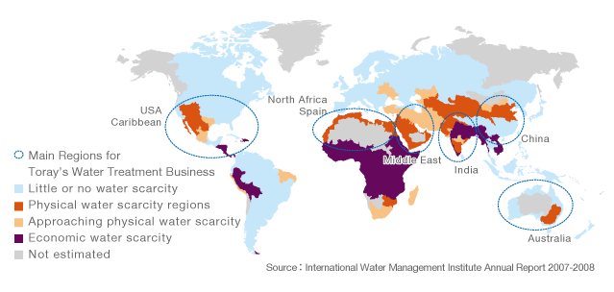
Conservation of Resources and Energy through Seawater Desalination with RO Membranes
An RO membrane is a high-performance water treatment membrane that separates pure water from water concentrate containing impurities such as saline matter. Only pure water is able to penetrate through the membrane, which blocks salt and other substance at the molecular level. Compared to conventional and widely-used thermal desalination systems that extract pure water by boiling seawater and cooling down the distilled water, the RO desalination method only requires one quarter the amount of source water, and less than one fifth the energy such as heat and electricity. As a highly efficient technology for freshwater production in terms of energy and resources, RO desalination is expected to contribute greatly towards global environmental protection. As of 2007, the accumulated reduction in CO₂ emissions resulting from the use of Toray's RO membranes installed around the world amounts to approximately 9.4 million tons. Assuming a continuation of the current rate of new RO desalination plant construction and switchover from thermal desalination, the resulting savings in CO₂ emissions is expected to be approximately 100 million tons by 2020.
CO₂ Emissions Reduction Resulting from Toray RO Membranes
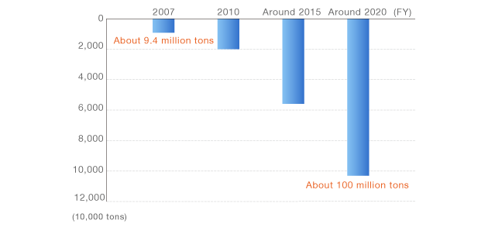
Striving to Resolve the World's Water Issues with Advanced Technology
Toray's RO membranes have been installed in a total of 100 plants around the world, mainly in large plants in 26 countries and regions. Based on the quantity of membranes sold to date (including those used for purposes other than seawater desalination), Toray's technology is responsible for producing 15.5 million cubic meters of water per day, or enough water to supply the household needs of about 65 million people (as of March 31, 2009). Toray is a founding member of the Global Water Recycle System Association Japan (see Column article) for the development and worldwide application of water recycling systems based on Japan's outstanding technology and expertise in this area. This recent movement is creating new opportunities for helping to solve the world's water issues. Given the realities of global warming and population growth, soon it will be difficult for human beings to continue relying only on natural water resources. Therefore, it is necessary to make effective use of limited global water resources by producing clean water through advanced technology. Toray Group will continue to expand its water treatment business based on its unique technologies, in order to contribute to solving global water resource issues.
Topics Relating to Water Treatment Membrane Technology
Providing Advanced Technologies from Japan to the World
In January 2009, the Global Water Recycling and Reuse System Association, was established as a Japanese cooperative system for solving water resource issues on a global scale. As of April 1, 2009, 38 companies involved in the water treatment business are listed as members of this association, including Toray Industries, Inc., Hitachi, Ltd., Kajima Corporation, Mitsubishi Corporation, and Hitachi Plant Technologies, Ltd. The aim is to establish a foundation for the business of water recycling and reuse systems that meets the needs of markets outside Japan. The association intends to do this by bringing together technology and expertise in water treatment membranes, while promoting cooperation with national and local governments, as well as research institutions. As a key company in this Japanese network, Toray is providing expertise and process technologies for water treatment that it has developed through related business activities around the world.
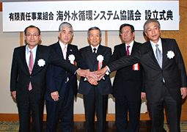
Establishing a Water Treatment Joint Venture in China
Toray and China National BlueStar (Group) Co., Ltd. agreed to form a joint venture water treatment business in Beijing through the establishment of Toray Blue Star Membrane Co., Ltd. in May 2009. The plan is to build facilities for the production of RO membranes and the assembly of membrane elements, with plant operations scheduled to begin in April 2010. Environmental pollution has become a serious issue for Chinese cities, due to rapid economic growth and industrialization in the country. The Chinese government considers the establishment of nationwide water treatment companies to be a pressing issue in order to secure safe water resources. As a partner of China National BlueStar Group, Toray is providing water treatment membranes and contributing towards environmental improvement in China.
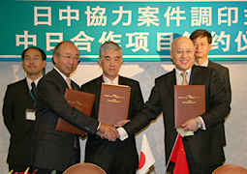
Related Information

